If you need 3rd line support from the lily product engineers.

<https://3rdlinesupport.ngdata.com/servicedesk/customer/portal/4>

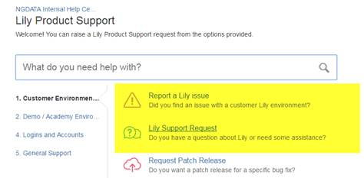

Some tips on filing a bug / issue:

<https://confluence.ngdata.com/display/SUPKB/Filing+a+bug+report>

(Note that SCB people **cannot access this**. They have a separate 1st line platform to access. <https://support.ngdata.com> . which Krishna has access to. And we need PSS to alsoo start using it)